Student worksheet

8.1 Earth’s gravity pulls objects to the centre of the Earth

Pages 144–145 and 210

Gravity

1 Write the definition of the following words:

a gravity

b gravitational field

c weight

d mass

e newton

Isaac Newton is pictured below on the day he first pondered the idea of gravity.

2 Using the diagram, explain why the apple fell to the ground.

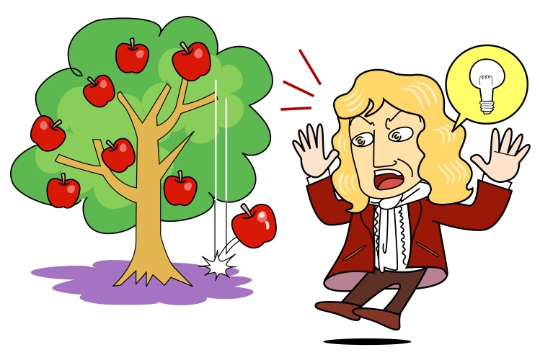

3 The apple has a mass of 200 grams. Using the diagram of the bricks as a guide, what would its weight be:

a on Earth? ____________________

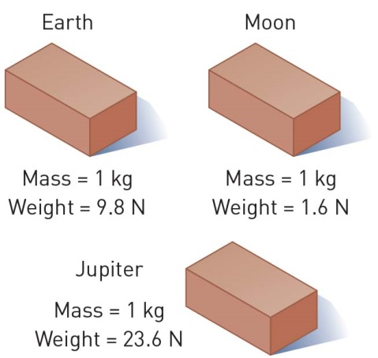b on the Moon? ____________________

c on Jupiter? ____________________

4 Assuming Newton’s mass was 60 kilograms, what was his weight:

a on Earth? ____________________

b on the Moon? ____________________

c on Jupiter? ____________________

5 In the space provided, draw a labelled diagram to explain why a tennis ball and a cricket ball would hit the ground at the same time when dropped from the same height.

|  |
| --- |
|  |

EXTEND YOUR UNDERSTANDING

6 What were another five discoveries made by Sir Isaac Newton?

Student worksheet

8.2 Gravity keeps planets in orbit around the Sun

Pages 146–147 and 211

Gravitational orbit

1 Use the information from the two diagrams below to explain the reason why the Moon orbits the Earth.

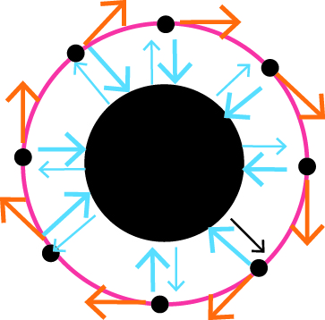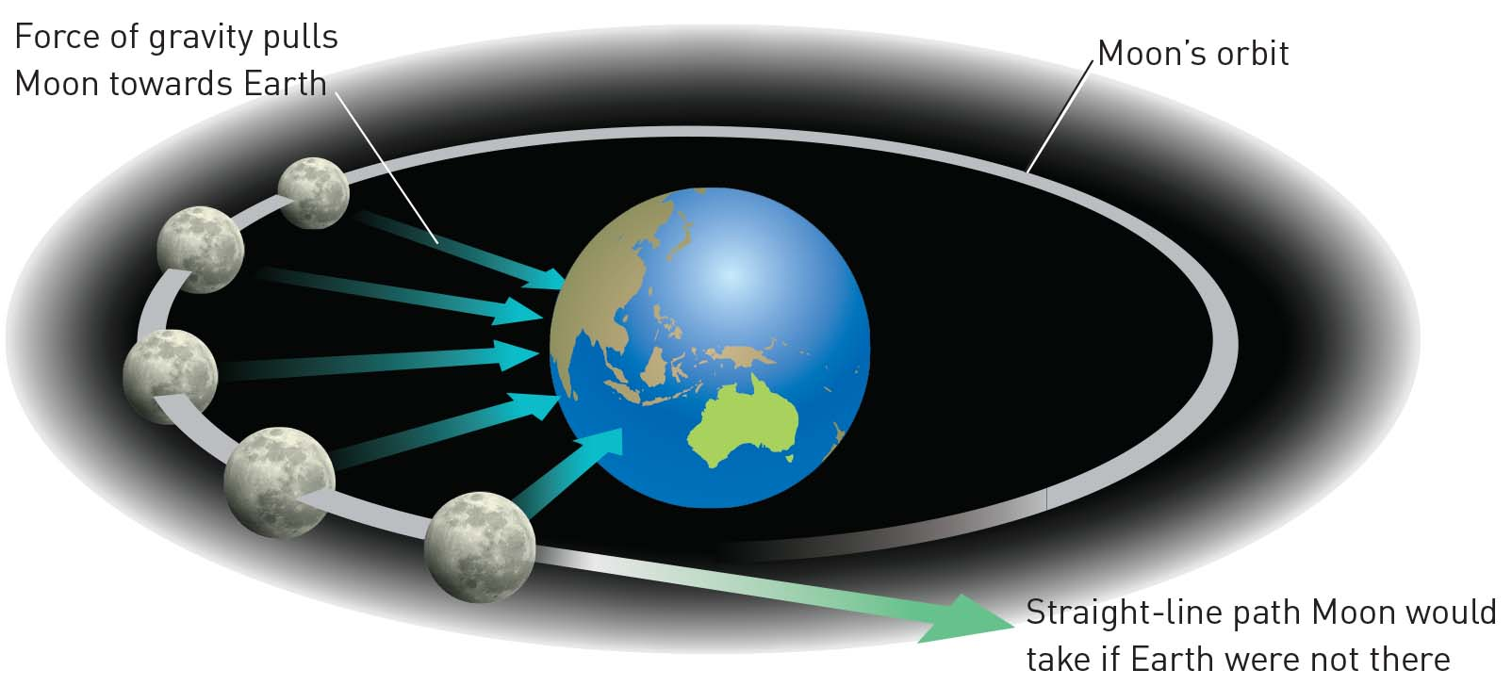

2 The Moon moves away from the Earth by approximately 3.7 cm per year. How far has it moved:

a since you were born?

b since either of your parents was born?

c since any of your grandparents were born?

3 If the Sun’s mass is 1000 times greater than that of Jupiter, and Jupiter’s mass is 317 times greater than that of the Earth, how much greater is the Sun’s mass than the Earth’s?

EXTEND YOUR UNDERSTANDING

4 In addition to confirming that the Earth travelled around the Sun, what were another three discoveries made by Galileo Galilei?

Student worksheet

8.3 The Moon’s gravity causes tidal movements

Pages 148–149

Tidal movement

1 The diagram below illustrates the influence that the Moon and the Sun have on the Earth’s tides. Fill in the boxes to explain the creation of tides (the orange bulge represents the Moon’s gravitational pull and the yellow bulge represents the Sun’s gravitational pull)

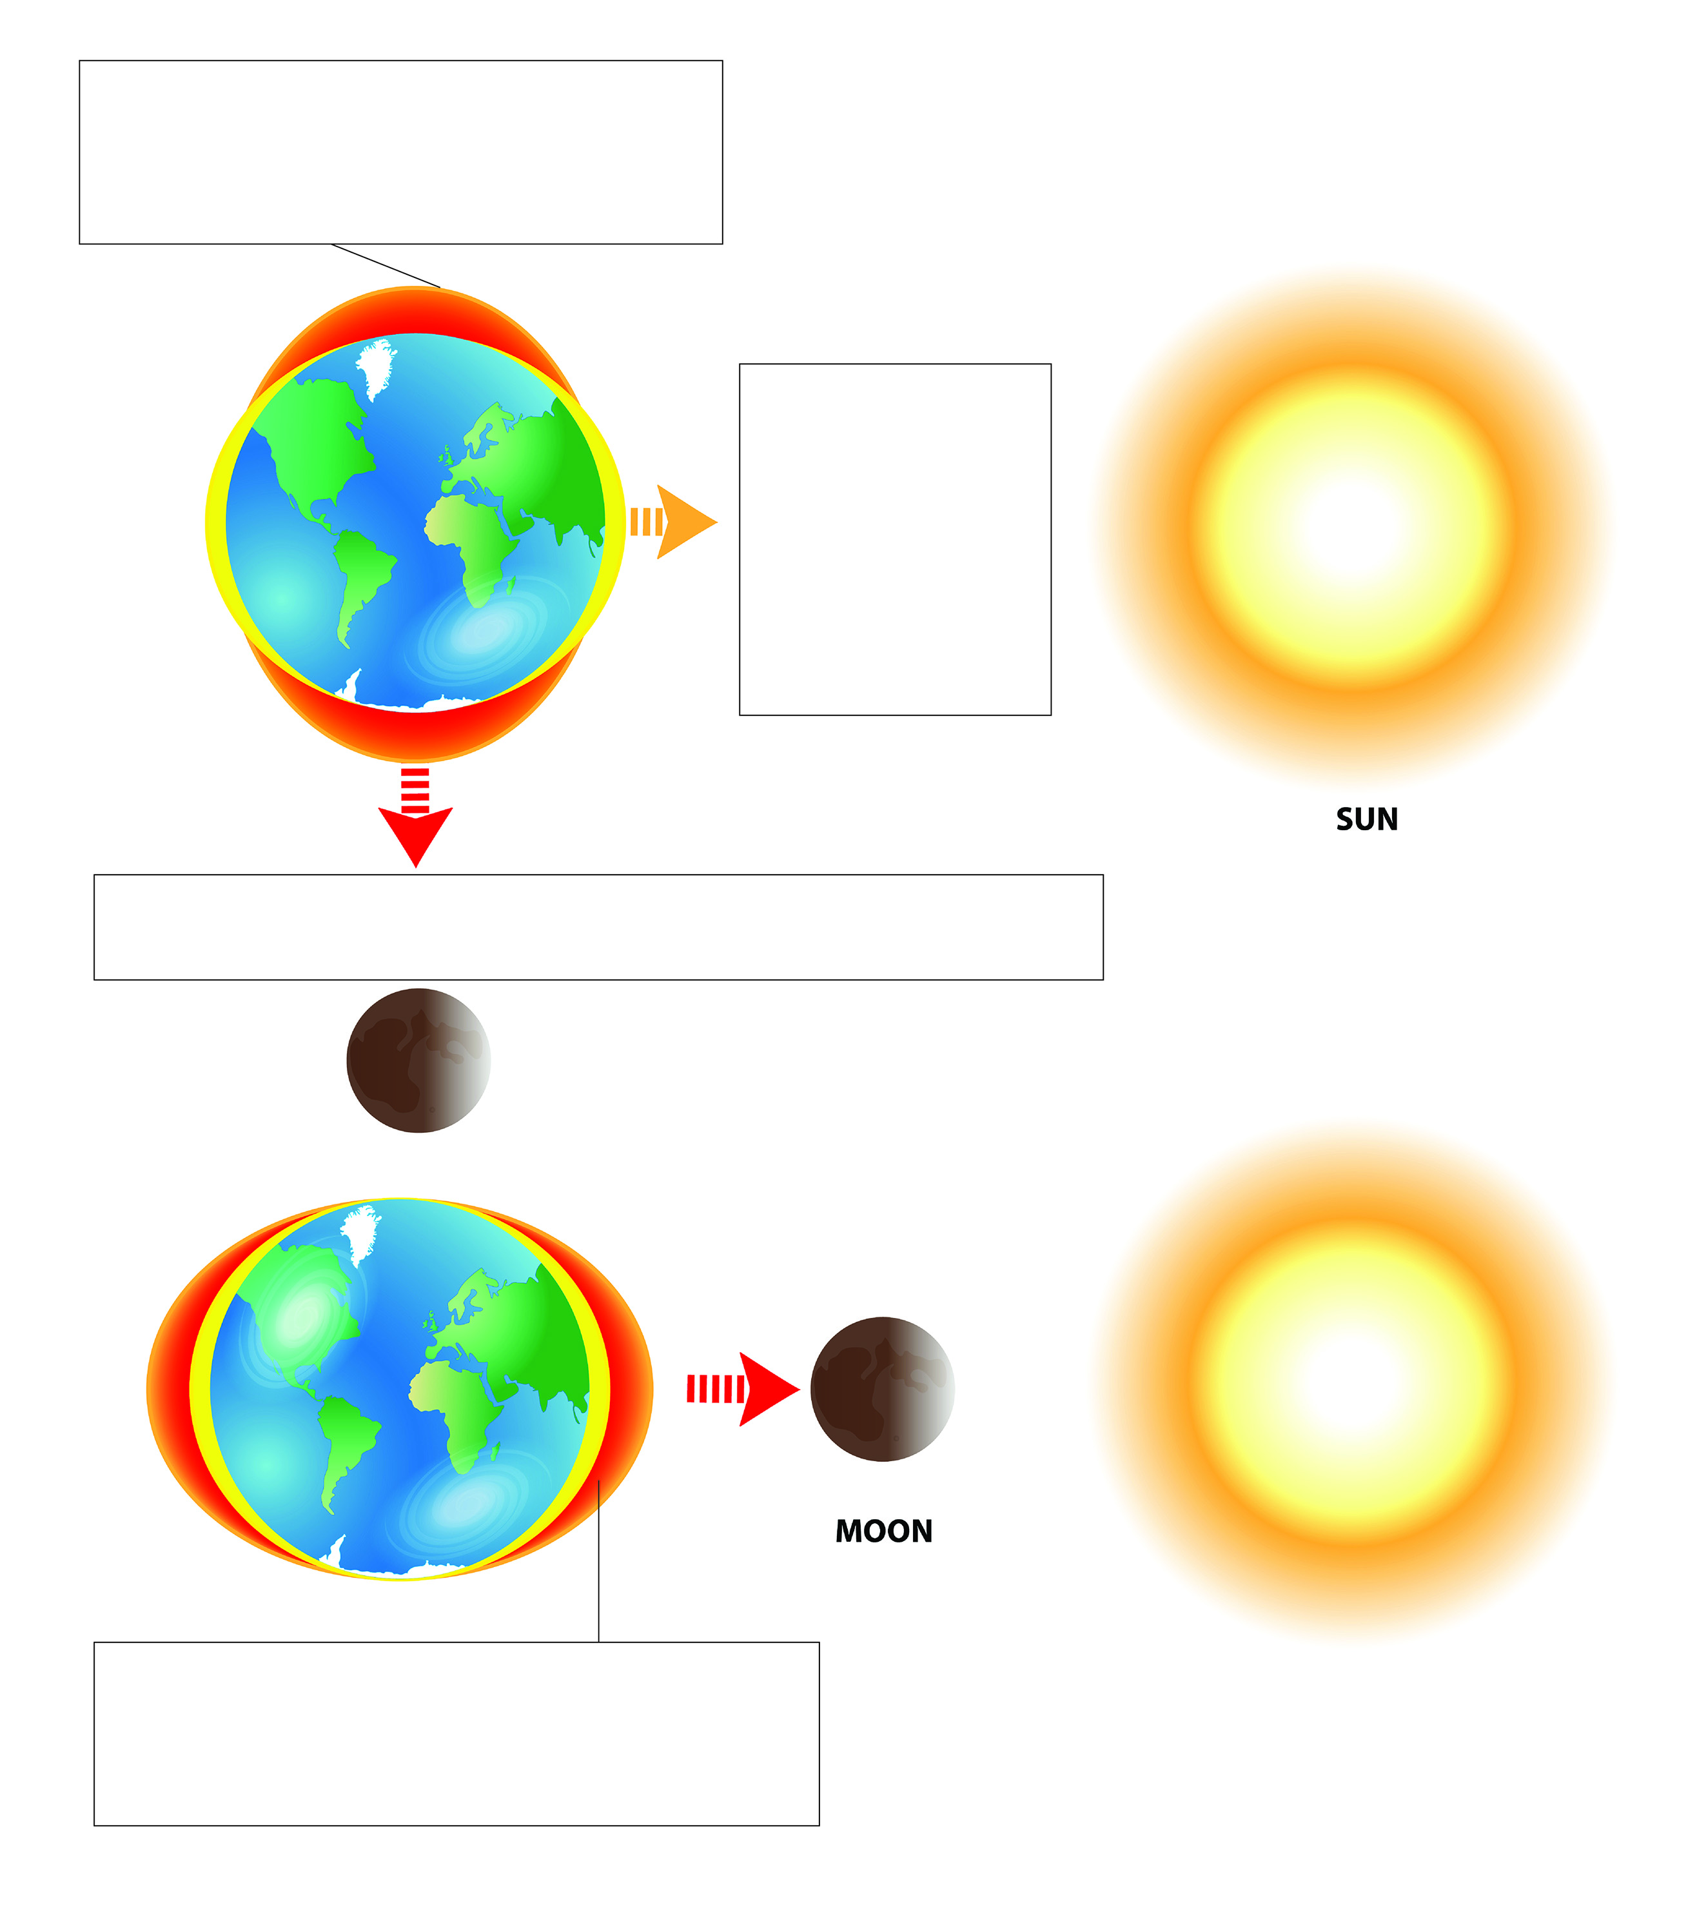

2 Even though the Sun is enormous compared with the mass and size of the Moon, the Moon has a greater effect on tides. Even though the Sun’s mass is 27 million times bigger than the Moon’s, it is 400 times further away from the Earth than the Moon. As a result, the Moon’s force is approximately 59 million greater than that of the Sun.

Use the information above and the calculation below work out the difference in tide-causing force.





Percentage of Sun’s vs Moon’s effect of tides = ___________ × 100

Percentage of Sun’s vs Moon’s effect of tides = ___________%

3 Do you think that spring tides only occur during the season of spring? Try to explain the reason for your answer.

EXTEND YOUR UNDERSTANDING

4 The cycles of the Moon can affect more than just the tides, especially when it is a full Moon. Research another four effects of a full Moon.

Student worksheet

8.4 Science as a human endeavour: Scientists work collaboratively to explore microgravity

Pages 150–151

Microgravity

1 Write four interesting facts about the International Space Station (ISS).

2 Label the picture with a summary of the effects of microgravity that the astronaut may experience.

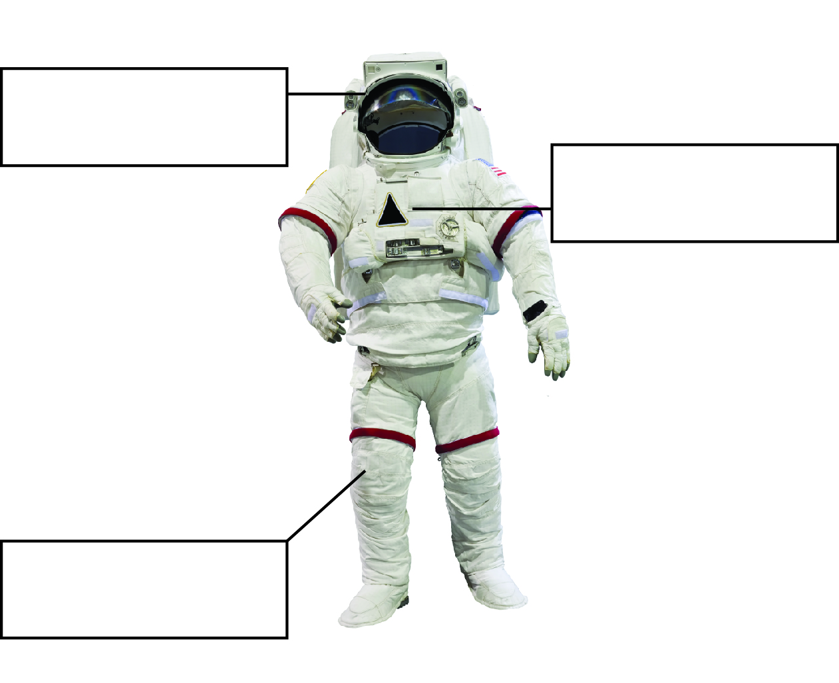

EXTEND YOUR UNDERSTANDING

4 Is there evidence of life on Mars? Undertake some research and write a brief summary of what you find out.